DarkTrace
Dark Web Monitoring Platform
Graduation Project Documentation
A Comprehensive Dark Web Intelligence and Cyber Threat Monitoring System
Prepared by
[Student Name]
[Supervisor Name]
[University Name] - [Department]
July 2026
Table of Contents
1.1 Project Introduction 7
1.2 Problem Statement 7
1.3 Our Solution & Objectives 8
1.4 Impact on Business 8
1.5 Ways of Marketing 9
1.6 Feasibility Study 9
1.6.1 Technical Feasibility 9
1.6.2 Operational Feasibility 9
1.6.3 Time Feasibility 10
1.7 Technical Study 10
1.7.1 Platform Subsystem 10
1.7.2 VM Subsystem 10
1.8 Economic Feasibility 11
1.9 Conclusion 11
2.1 Introduction 12
2.2 Related Works 12
2.2.1 Commercial Solutions 12
Have I Been Pwned (HIBP) 12
Credit Bureau Dark Web Monitoring (Experian, Equifax, TransUnion) 12
Enterprise SIEM & Threat Intelligence (Splunk, IBM QRadar, Recorded Future) 12
2.2.2 Open Source Tools 12
TheHive & Cortex 12
MISP 12
Custom Python Scrapers 12
2.3 System Architecture 13
2.4 Project Features 13
2.5 Project Benefits 13
2.6 Project Risk Management 13
3.1 Software Development Life Cycle 15
3.2 Development Chosen Methodology 15
3.3 Applications Chosen Methodology 15
3.3.1 Scrum Framework 15
3.3.2 Version Control & Collaboration 16
3.3.3 Testing Strategy 16
4.1 Project App Design 17
4.1.1 Design Principles 17
4.2 User Interface (UI) 17
4.2.1 Public Pages 17
4.2.2 Authentication Pages 18
4.2.3 Dashboard 18
4.2.4 Exposure Center 18
4.2.5 Profile & Settings 19
4.3 User Experience (UX) 19
4.3.1 Monitoring Workflow 20
4.3.2 Alert Management 20
4.3.3 Search & Intelligence 20
5.1 Introduction 21
5.2 Purpose of Document 21
5.3 Project Requirements Analysis 22
5.3.1 Functional Requirements 22
5.3.2 Non-Functional Requirements 22
5.4 Software Architecture [ERD] 22
5.4.1 Platform Database Schema 23
User & Organization 23
Exposure & Breach Data 23
Alert & Notification 23
5.4.2 Elasticsearch Data Model 23
5.5 Data Flow Diagram 24
5.5.1 Data Collection Layer 24
5.5.2 Data Processing Layer 25
5.5.3 Data Presentation Layer 25
5.6 System Design [Use Case Diagram] 25
5.6.1 Actor Identification 25
5.6.2 Primary Use Cases 26
5.7 Sequence Diagram 26
5.7.1 Asset Search Flow 26
5.7.2 Alert Generation Flow 27
6.1 Platform Technologies 30
6.1.1 Laravel Framework 30
6.1.2 Frontend Stack 30
6.1.3 Database Technologies 30
6.2 VM Technologies 30
6.2.1 Python Ecosystem 31
6.2.2 Elasticsearch 31
6.2.3 Redis 31
6.2.4 RabbitMQ 31
6.2.5 Ollama & AI Integration 31
6.2.6 ripgrep (rg) 31
6.3 Infrastructure & Deployment 31
7.1 Platform Testing 33
7.1.1 Test Framework 33
7.1.2 Test Execution 33
7.1.3 Development Test Scripts 33
7.2 VM Component Testing 34
7.2.1 Smoke Tests 34
7.2.2 Parser Testing 34
7.2.3 Telegram Bot Parsing Testing 34
7.2.4 ULP Processor Testing 34
7.3 Integration Testing 34
8.1 Future Work Features 35
8.1.1 Advanced Analytics & Machine Learning 35
8.1.2 Enhanced Data Sources 35
8.1.3 Platform Enhancements 35
8.1.4 Security Enhancements 35
8.2 Future Plans 35
8.2.1 Market Expansion 35
8.2.2 Technical Evolution 35
8.3 Impact of The Future Work on Project 36
8.4 Conclusion 36
Abstract
The exponential growth of cyber threats and the proliferation of underground digital marketplaces have created an urgent need for proactive, automated dark web monitoring systems. Data breaches, credential leaks, and infostealer malware campaigns expose billions of personal and corporate records annually, yet most organizations and individuals lack real-time visibility into whether their compromised data is being traded or exploited on the dark web. Traditional breach notification services offer only reactive, historical checks and fail to cover the diverse range of sources - Telegram channels, infostealer logs, combolist databases, and dark web forums - where stolen data actively circulates.
DarkTrace is a comprehensive dark web intelligence and cyber threat monitoring platform designed to bridge this critical visibility gap. The system employs a distributed architecture comprising two primary subsystems: a Laravel 12-based web application that delivers a full-featured user interface, dashboard, alerting engine, and enterprise management tools; and a Python-powered monitoring Virtual Machine that orchestrates all data collection, parsing, processing, and intelligence gathering operations. The platform monitors data across four Telegram bot workers (ak-bot, busc-bot, chatle-bot, def-bot), a 2.4-billion-record ULP combolist search engine driven by ripgrep, a RabbitMQ-powered breach ingestion pipeline with multi-stage classification and parsing, and a dark web forum crawler storing results in MongoDB.
All collected data flows through a structured processing pipeline: raw inputs are classified by type, parsed through specialized handlers (text, structured tables, SQL dumps, JSON), normalized into a consistent schema, deduplicated using SHA-256 hashing, and indexed into Elasticsearch for high-performance full-text search and aggregation. The platform supports ten distinct exposure categories - including email addresses, passwords, financial data, phone numbers, physical addresses, identity numbers, IP addresses, usernames, hardware identifiers, and domain exposures - each with source attribution, breach timelines, and severity scoring. Real-time alerting is delivered through the web dashboard, Telegram bot integration, and email notifications, enriched with AI-powered insights generated by a locally-hosted Ollama LLM.
Key achievements include the successful integration of four Telegram bot workers with independent Elasticsearch indexers and Redis queue consumers; an intelligent three-stage parsing engine combining regex extraction, knowledge-base cached patterns, and AI fallback for anomalous lines; a production-grade breach ingestion daemon with automated archive extraction, forensic metadata indexing, and schema auto-recovery; and a comprehensive enterprise feature set encompassing organization management, DNS-based domain verification, team collaboration, multi-factor authentication (TOTP), and scheduled PDF/CSV/JSON report generation.
The system is built entirely on open-source technologies - Laravel, Python, Elasticsearch, Redis, RabbitMQ, and Telethon - eliminating licensing costs while ensuring scalability and community support. The modular microservice-inspired architecture allows independent scaling of each component, with queue-based communication between the platform and VM layers enabling asynchronous, fault-tolerant operation. DarkTrace demonstrates that comprehensive, real-time dark web monitoring is achievable using accessible technologies, providing a practical and scalable solution for individuals and organizations seeking to protect their digital assets against the growing threat of data breaches and credential exposure in the underground cybercriminal ecosystem.
Keywords: Dark Web Monitoring, Cyber Threat Intelligence, Data Breach Detection, Credential Leak Monitoring, Infostealer Malware, Elasticsearch, Laravel, Telegram Bot, Python Data Pipeline, Multi-Factor Authentication, Information Security

Chapter 1: Introduction

1.1 Project Introduction
The rapid growth of cybercrime has made data breaches, credential leaks, and identity theft among the most significant cybersecurity challenges facing individuals, businesses, and governments. Every year, billions of compromised records are exposed through security breaches and malware campaigns, with much of this information being traded and distributed on dark web marketplaces, underground forums, Telegram channels, and other hidden communication platforms. As a result, organizations require proactive threat intelligence solutions capable of detecting exposed credentials before they are exploited by attackers.
DarkTrace is a comprehensive Dark Web Monitoring Platform developed to address this growing challenge by continuously collecting, processing, and analyzing cyber threat intelligence from multiple underground sources. The platform monitors dark web forums, Telegram channels, infostealer logs, and breach databases to identify leaked credentials, compromised accounts, and sensitive information that may pose a security risk to individuals and organizations. By providing real-time monitoring, exposure reports, and searchable threat intelligence, the system enables users to respond quickly and reduce the potential impact of cyber incidents.
The platform is designed using a distributed architecture composed of two primary components. A Laravel-based web application provides user management, dashboards, search capabilities, reporting, and administrative functions, while a dedicated Python-based monitoring environment is responsible for crawling dark web sources, collecting threat data, parsing heterogeneous datasets, and processing intelligence gathered from multiple channels. This modular architecture improves scalability, maintainability, and fault tolerance while allowing each component to operate independently.
To efficiently manage the large volume of collected information, the platform utilizes Elasticsearch as its primary indexing and search engine, enabling high-performance queries across massive breach datasets. The system also incorporates artificial intelligence through Ollama and the Qwen2.5:3B large language model to automatically identify, normalize, and process different data structures encountered during data collection. This AI-assisted schema discovery significantly reduces manual configuration efforts and allows the platform to adapt to new data sources with minimal human intervention.
The platform supports both individual users through a Personal Plan and organizations through an Enterprise Plan, providing different monitoring capabilities based on user requirements. Individuals can monitor personal assets such as email addresses and usernames, while organizations can protect domains, employee accounts, and other critical digital assets through continuous monitoring and comprehensive reporting.
This graduation project follows a structured software engineering methodology, including requirements analysis, system design, implementation, testing, and evaluation. The following sections introduce the problem statement, project objectives, scope, and feasibility studies that form the foundation of the DarkTrace Dark Web Monitoring Platform.
[SCREENSHOT PLACEHOLDER]
Description: DarkTrace Home Page showing the landing page with hero section, platform overview, and call-to-action buttons for sign-up and demo request.

1.2 Problem Statement
The rapid growth of cybercrime has significantly increased the number of data breaches, credential leaks, and identity theft incidents worldwide. Stolen credentials, personal information, and sensitive corporate data are frequently traded through dark web forums, underground marketplaces, Telegram channels, and other hidden communication platforms. Unfortunately, many organizations and individuals remain unaware that their data has been compromised until attackers exploit it, often resulting in financial losses, reputational damage, and regulatory consequences.
Traditional cybersecurity solutions, such as firewalls, antivirus software, and intrusion detection systems, primarily focus on preventing attacks within organizational networks. However, they provide limited visibility into data that has already been stolen and is being distributed across underground platforms. This creates a significant visibility gap, making it difficult for organizations to detect compromised credentials before they are misused.
Another major challenge is the enormous volume and diversity of threat intelligence data generated daily. Information appears in multiple formats, including breach databases, credential lists, infostealer logs, SQL dumps, CSV files, JSON exports, and unstructured forum posts. Manually monitoring these sources is impractical due to the scale of available data, the dynamic nature of dark web communities, and the continuous emergence of new data formats.
Furthermore, organizations often struggle to monitor their complete attack surface, including employee credentials, corporate domains, email addresses, IP addresses, and other digital assets. Without an automated monitoring platform, threat detection remains reactive rather than proactive, increasing the likelihood of successful cyberattacks.
Therefore, there is a growing need for an intelligent, automated, and scalable platform capable of continuously collecting, processing, and analyzing threat intelligence from multiple underground sources while providing timely alerts and actionable insights.

1.3 Our Solution & Objectives
DarkTrace is a comprehensive Dark Web Monitoring Platform developed to address the challenges of detecting compromised credentials and exposed digital assets. The platform integrates automated data collection, intelligent processing, high-performance searching, and real-time alerting into a unified threat intelligence solution.
The main objectives of the project are:
- Develop an automated monitoring system capable of continuously collecting threat intelligence from dark web forums, Telegram channels, breach databases, and infostealer logs.
- Build a scalable data processing pipeline that extracts, parses, normalizes, and indexes collected information for efficient searching and analysis.
- Provide real-time alerts whenever monitored assets such as email addresses, usernames, domains, or other identifiers are detected within newly collected breach data.
- Support both individual users and enterprise organizations through a multi-tenant architecture with different monitoring capabilities and reporting features.
- Deliver actionable threat intelligence through exposure reports, risk assessment, AI-assisted analysis, and remediation recommendations.
- Design a modular and extensible architecture that allows new monitoring sources, parsers, and analytical capabilities to be integrated with minimal modifications.
- Utilize artificial intelligence to improve data normalization and automatically adapt to previously unseen data formats.

1.4 Impact on Business
The DarkTrace platform provides significant value to organizations by enabling proactive identification of compromised credentials before attackers can exploit them. Early detection allows security teams to perform password resets, revoke compromised sessions, and strengthen security controls, reducing the overall impact of cyber incidents.
The platform also assists organizations in meeting regulatory and compliance requirements, including data protection regulations such as GDPR and CCPA, by supporting timely breach detection and incident response.
Continuous monitoring improves the overall security posture by providing visibility into external threats targeting organizational assets. Automated threat intelligence collection reduces manual workload for security teams, allowing them to focus on incident response and strategic security improvements.
Additionally, preventing successful credential-based attacks helps reduce financial losses, protect organizational reputation, and strengthen customer trust.

1.5 Ways of Marketing
The proposed marketing strategy focuses on increasing awareness and adoption of the platform among both individuals and organizations through multiple channels:
- Publishing cybersecurity articles, breach analysis reports, and threat intelligence research.
- Participating in cybersecurity conferences, workshops, and professional communities.
- Offering a freemium model that allows users to experience the platform before purchasing premium features.
- Promoting enterprise solutions through demonstrations, proof-of-concept deployments, and direct business engagement.
- Establishing partnerships with Managed Security Service Providers (MSSPs), cybersecurity consultancies, and other security vendors.

1.6 Feasibility Study

1.6.1 Technical Feasibility
The project utilizes mature and widely adopted technologies that have been successfully deployed in production environments. The selected technologies provide high scalability, reliability, strong community support, and extensive documentation. Modern frameworks and distributed processing techniques ensure that the platform can efficiently handle large volumes of threat intelligence data while maintaining high performance.

1.6.2 Operational Feasibility
The system is designed for automated operation with minimal manual intervention. The monitoring VM runs as a daemon process consuming jobs from Redis queues. The web platform handles user management and data presentation through a modern interface. Scheduled tasks automate routine operations.
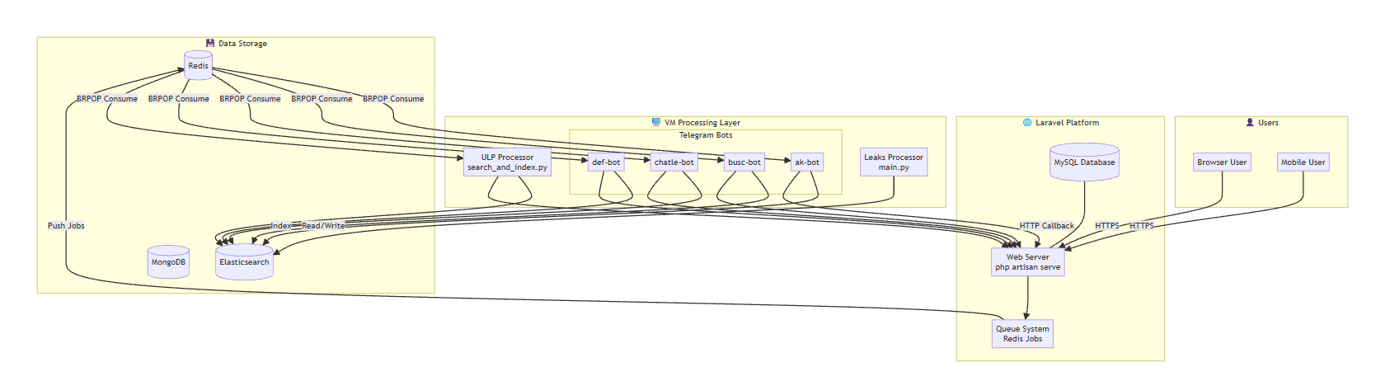
System Architecture

1.6.3 Time Feasibility
The project was developed in iterative phases, each building on the previous one: core platform features (authentication, dashboard, exposure management), enterprise features, Telegram integration, AI-powered insights, and VM monitoring components.

1.7 Technical Study

1.7.1 Platform Subsystem
The Platform subsystem is built with Laravel 12. Key technical components include:
- Elasticsearch as the primary data store for breach and exposure records, providing powerful full-text search and aggregation capabilities.
- SQLite for local development and MySQL/PostgreSQL for production database needs.
- Redis for caching, session management, and as a message queue for job distribution.
- Laravel Sanctum for API token authentication and session management.
- Alpine.js and Tailwind CSS for the frontend, providing a reactive, responsive user interface.
- DOMPDF for PDF report generation.
- Google2FA library for TOTP-based multi-factor authentication.
- Laravel Socialite for social login integration (Microsoft, Google).

1.7.2 VM Subsystem
- Python 3.11+ for all monitoring scripts and data processing pipelines.
- Telethon library for Telegram bot integration, enabling automated data collection from Telegram channels.
- Elasticsearch Python client for indexing processed data.
- RabbitMQ for message queuing in the breach processing pipeline.
- Redis Python client for consuming jobs from the platform's Redis queues.
- ripgrep (rg) for ultra-fast pattern searching in large breach database files.
- Ollama with locally-hosted LLM models for AI-based column detection and parsing.
- pika for RabbitMQ consumer daemon interaction.

1.8 Economic Feasibility
- Infrastructure Costs: The platform can run on standard VPS or cloud infrastructure.
- Open Source Technologies: All core technologies are open source, eliminating licensing costs.
- Revenue Model: Subscription-based with Personal and Enterprise tiers.
- Value Proposition: More accessible than enterprise-grade platforms costing tens of thousands annually.

1.9 Conclusion
DarkTrace addresses a critical need in the cybersecurity landscape by providing an automated, comprehensive dark web monitoring platform accessible to both individuals and organizations. The subsequent chapters provide detailed technical explanations of every component.

Chapter 2: Related Works

2.1 Introduction
Cybersecurity organizations increasingly rely on threat intelligence platforms to detect compromised credentials, monitor underground activities, and identify emerging cyber threats. Numerous commercial and open-source solutions have been developed to address different aspects of dark web monitoring. However, these solutions vary significantly in terms of data coverage, monitoring capabilities, scalability, and accessibility.
This chapter reviews the most relevant existing solutions, compares their capabilities with the proposed DarkTrace platform, and highlights the unique features that distinguish the proposed system.

2.2 Related Works

2.2.1 Commercial Solutions

Have I Been Pwned (HIBP)
Have I Been Pwned (HIBP), developed by Troy Hunt, is one of the most widely used breach notification services. It enables users to verify whether their email addresses or passwords have appeared in publicly disclosed data breaches. Although HIBP is highly valuable for historical breach verification, it primarily relies on previously published breach datasets and does not continuously monitor underground communities, Telegram channels, or infostealer logs.

Credit Bureau Monitoring Services
Several credit monitoring providers, including Experian, Equifax, and TransUnion, offer dark web monitoring services focused on protecting customers from identity theft and financial fraud. These services mainly monitor personal and financial information but provide limited visibility into credential leaks, malware logs, and underground discussion forums.

Enterprise Threat Intelligence Platforms
Enterprise platforms such as Splunk, IBM QRadar, and Recorded Future provide comprehensive threat intelligence and security monitoring capabilities. These systems integrate with Security Operations Centers (SOCs) and support advanced analytics, correlation, and incident response. However, they generally require significant financial investment, specialized infrastructure, and experienced security personnel.

2.2.2 Open Source Tools

TheHive and Cortex
TheHive and Cortex are popular open-source incident response and security orchestration platforms. While they provide powerful case management and automation capabilities, they rely on external integrations to collect dark web intelligence and do not include built-in monitoring components.

MISP
The Malware Information Sharing Platform (MISP) is an open-source threat intelligence platform designed for sharing indicators of compromise among security organizations. Although it facilitates intelligence exchange, it does not natively collect information from dark web sources.

Custom Python Scrapers
Many organizations develop custom web crawlers and Python scripts to collect threat intelligence from underground sources. Although these solutions provide flexibility, they typically require continuous maintenance and lack integrated dashboards, alerting mechanisms, centralized management, and user-friendly interfaces.

2.3 System Architecture
The following table compares DarkTrace with existing solutions:
Feature | DarkTrace | HIBP | Credit Bureaus | Enterprise SIEM
Real-time monitoring | ✓ | ✗ | ✗ | ✓
Telegram monitoring | ✓ | ✗ | ✗ | ✗
Dark web forums | ✓ | ✗ | ✓ | ✓
Infostealer logs | ✓ | ✗ | ✗ | ✗
2.4B ULP combolists | ✓ | ✗ | ✗ | ✗
AI-powered parsing | ✓ | ✗ | ✗ | ✓
Personal users | ✓ | ✓ | ✓ | ✗
Enterprise users | ✓ | ✗ | ✓ | ✓
Open-source stack | ✓ | ✗ | ✗ | ✗
Free tier | ✓ | ✓ | ✗ | ✗

Table: Comparison of DarkTrace with existing solutions

2.4 Project Features
Potential risks associated with the project and the corresponding mitigation strategies are summarized below.
Risk | Impact | Mitigation Strategy
False Positives | Medium | AI-assisted validation, confidence scoring, and configurable alert thresholds
Data Processing Errors | Medium | Multi-stage validation, automatic schema detection, and detailed logging
Service Downtime | High | Distributed architecture, background workers, and automatic recovery mechanisms
Data Privacy Risks | Critical | Encryption, access control, audit logging, and data masking
Search Engine Failure | Medium | Health monitoring, retry mechanisms, and fault-tolerant processing
External API Changes | Low | Modular integration design and independent service components
Scalability Challenges | Medium | Distributed processing, queue-based architecture, and horizontal scalabilityPotential risks associated with the project and the corresponding mitigation strategies are summarized below.| Risk | Impact | Mitigation Strategy || --- | --- | --- || False Positives | Medium | AI-assisted validation, confidence scoring, and configurable alert thresholds || Data Processing Errors | Medium | Multi-stage validation, automatic schema detection, and detailed logging || Service Downtime | High | Distributed architecture, background workers, and automatic recovery mechanisms || Data Privacy Risks | Critical | Encryption, access control, audit logging, and data masking || Search Engine Failure | Medium | Health monitoring, retry mechanisms, and fault-tolerant processing || External API Changes | Low | Modular integration design and independent service components || Scalability Challenges | Medium | Distributed processing, queue-based architecture, and horizontal scalability |The DarkTrace platform offers several key features designed to improve cyber threat detection and exposure management:

- Continuous monitoring of dark web forums, Telegram channels, breach databases, and infostealer logs.
- Automated data collection, parsing, normalization, and indexing.
- High-performance search engine for rapid retrieval of breach information.
- AI-assisted analysis for processing heterogeneous data formats.
- Real-time alerts through the web platform, email, and Telegram notifications.
- Comprehensive exposure reports with risk assessment and remediation guidance.
- Enterprise asset monitoring, including domains, email addresses, IP addresses, and organizational keywords.
- Multi-factor authentication and secure user account management.
- Scheduled report generation in multiple export formats.

2.5 Project Benefits
- Proactive security posture through early detection.
- Accessible pricing for individuals and small businesses.
- Comprehensive multi-source coverage.
- User-friendly interface for non-technical users.
- Automated operations requiring minimal intervention.

2.6 Project Risk Management
Potential risks associated with the project and the corresponding mitigation strategies are summarized below.
Risk | Impact | Mitigation Strategy
False Positives | Medium | AI-assisted validation, confidence scoring, and configurable alert thresholds
Data Processing Errors | Medium | Multi-stage validation, automatic schema detection, and detailed logging
Service Downtime | High | Distributed architecture, background workers, and automatic recovery mechanisms
Data Privacy Risks | Critical | Encryption, access control, audit logging, and data masking
Search Engine Failure | Medium | Health monitoring, retry mechanisms, and fault-tolerant processing
External API Changes | Low | Modular integration design and independent service components
Scalability Challenges | Medium | Distributed processing, queue-based architecture, and horizontal scalability

Table: Risk management matrix
Chapter 3: Project Development Methodology

3.1 Software Development Life Cycle
The Software Development Life Cycle (SDLC) provides a systematic framework for planning, developing, testing, deploying, and maintaining software systems. Selecting an appropriate SDLC model is essential to ensure that software is delivered efficiently while meeting functional and non-functional requirements.
Several SDLC models are commonly adopted in software engineering projects. The Waterfall model follows a sequential process in which each phase must be completed before the next begins. Although it provides clear documentation and structured development, it offers limited flexibility when requirements change during development.
The Iterative model improves flexibility by developing the software through repeated cycles, allowing gradual refinement based on testing and feedback. Similarly, the Spiral model combines iterative development with risk analysis, making it suitable for large and high-risk projects, although it requires significant planning and management effort.
Modern software projects increasingly adopt Agile methodologies, which emphasize iterative development, continuous feedback, customer collaboration, and adaptability to changing requirements. Frameworks such as Scrum enable development teams to deliver working software in short development cycles while continuously improving the product.
In addition to Agile, DevOps practices support continuous integration, automated testing, and reliable deployment. Together, Agile and DevOps provide an effective development methodology for distributed systems that require frequent updates, scalability, and high reliability.
Considering the dynamic nature of cybersecurity and dark web monitoring, Agile combined with DevOps represents the most appropriate methodology for developing the proposed system.

3.2 Development Chosen Methodology
DarkTrace was developed using a hybrid Agile–Scrum methodology supported by DevOps practices. This approach was selected because cybersecurity environments continuously evolve, requiring software systems to adapt rapidly to new threats, changing data sources, and emerging technologies.
The Agile methodology provided several advantages throughout the development process:
- Adaptability: New requirements and monitoring capabilities could be incorporated without disrupting the overall project.
- Incremental Development: The platform was implemented in small functional iterations, allowing continuous testing and validation.
- Risk Reduction: Technical challenges were identified and addressed during early development phases.
- Continuous Feedback: Regular reviews enabled improvements based on testing results and project evaluation.
- Improved Collaboration: Team members worked collaboratively through regular meetings, task planning, and progress reviews.
The project was developed through the following iterative phases:

Phase 1 – Core Platform Development
Implementation of authentication, user management, database design, dashboards, and the basic system architecture.

Phase 2 – Threat Intelligence Processing
Development of automated data collection, parsing, normalization, indexing, and search capabilities.

Phase 3 – Alerting and Notification Services
Implementation of real-time alert generation, email notifications, and Telegram integration.

Phase 4 – Enterprise Monitoring Features
Development of organizational asset monitoring, domain management, and enterprise-specific functionality.

Phase 5 – Distributed Processing Infrastructure
Integration of background workers, task queues, and communication between monitoring services and the web platform.

Phase 6 – Advanced Features
Implementation of reporting, AI-assisted analysis, password security evaluation, and additional security enhancements.

3.3 Applications Chosen Methodology

3.3.1 Scrum Framework
The Scrum framework was adapted throughout the project to organize development activities into iterative development cycles (sprints). Each sprint began with planning sessions to define objectives and assign development tasks according to project priorities.
Daily meetings were conducted to monitor progress, discuss technical challenges, and coordinate development activities among team members. At the end of each sprint, review meetings were held to evaluate completed functionality and collect feedback, followed by retrospective meetings to identify process improvements for subsequent iterations.

3.3.2 Version Control & Collaboration
Git was used as the primary version control system throughout the project. Feature branching allowed developers to implement new functionality independently before merging verified code into the main development branch.
Code reviews and collaborative development practices helped improve software quality, reduce integration issues, and maintain a consistent coding standard across all project components.

3.3.3 Testing Strategy
- Unit Testing: PHPUnit/Pest for Laravel, Python unittest for VM components.
- Integration Testing: Elasticsearch query testing, Redis queue integration, API endpoint testing.
- Smoke Testing: Python _smoke_test.py for VM component validation.
- End-to-End Testing: Full pipeline from data collection to alert generation using test data.
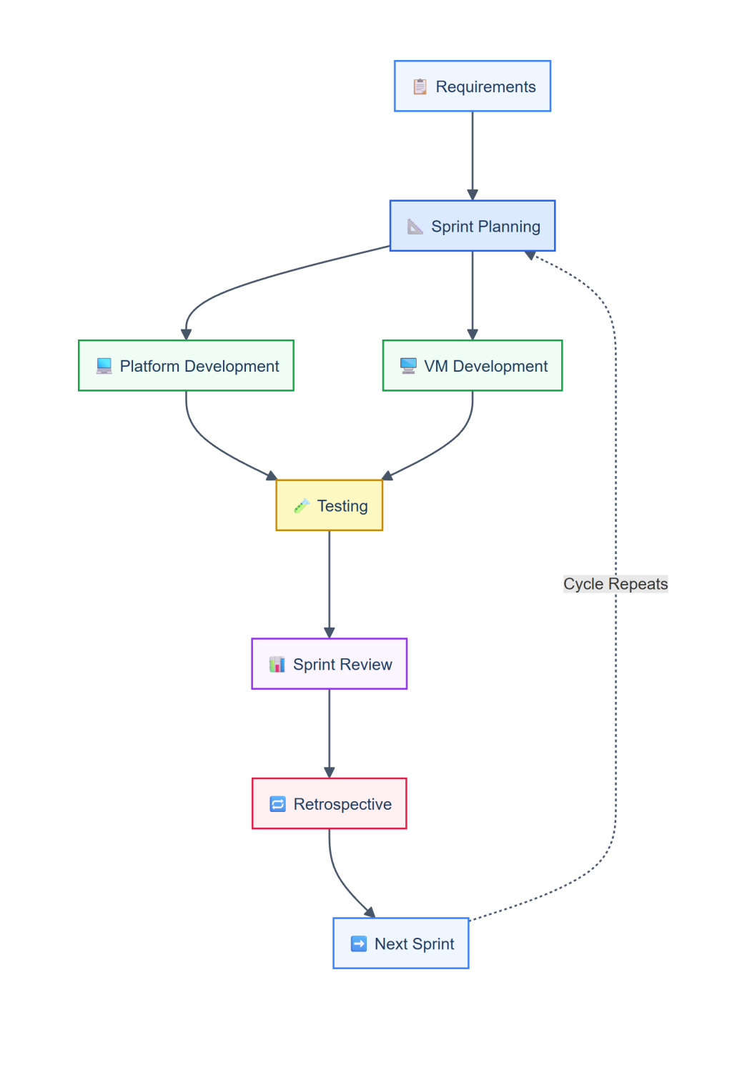
Development Methodology Flow
Chapter 4: Project Interface Design

4.1 Project App Design
The user interface of DarkTrace was designed following modern web application principles with a strong emphasis on usability, security, and responsiveness. Since the platform targets cybersecurity professionals as well as individual users, the interface was designed to provide quick access to threat intelligence while maintaining a simple and intuitive user experience.
The application adopts a dashboard-centered design that allows users to monitor security status, review recent alerts, search breach data, and manage monitored assets from a single interface. A dark-themed visual style was selected to align with cybersecurity industry standards while reducing eye strain during extended usage.
The main design principles adopted throughout the platform include:
- Security-Oriented Design: Sensitive information is masked by default and requires additional verification before being displayed.
- Clear Information Presentation: Threat intelligence is organized using tables, charts, cards, and visual indicators to simplify analysis.
- Responsive Layout: All interfaces are fully responsive and support desktop, tablet, and mobile devices.
- Consistency: A unified design language is maintained across all pages using reusable components and standardized layouts.
- Accessibility: Readable typography, clear navigation, and high-contrast color schemes improve usability for all users.

4.1.1 Design Principles
- Security-First Visual Language: Dark-themed palette with accent colors conveying severity levels (red=critical, orange=high, yellow=medium, green=low).
- Data Clarity: Complex threat data presented through clear visual hierarchies, charts, and organized tables with node-graph visualizations.
- Progressive Disclosure: Sensitive data masked by default, requiring password re-verification to view.
- Responsive Design: Fully responsive across desktop, tablet, and mobile.

4.2 User Interface (UI)

4.2.1 Public Pages
Page | Route | Purpose
Home | / | Landing page with platform overview and call-to-action
Features | /features | Detailed feature listing
Pricing | /pricing | Subscription plan comparison
About | /about | Platform information
Blog | /blog | Security blog and breach analysis
Contact | /contact | Contact form and support
FAQ | /faq | Frequently asked questions
Documentation | /docs | Platform documentation
Demo Request | /request-demo | Enterprise demo request

Table: Public pages of DarkTrace
[SCREENSHOT PLACEHOLDER]
Description: DarkTrace Public Home Page showing the hero section with tagline, feature highlights, and pricing/CTA buttons.
[SCREENSHOT PLACEHOLDER]
Description: DarkTrace Pricing Page showing the Personal vs Enterprise plan comparison with features and monthly pricing.

4.2.2 Authentication Pages
- Login Page: Email/password login with remember-me, social login via Microsoft and Google.
- Registration: Separate flows for Personal and Enterprise accounts with organization details and domain verification.
- MFA Challenge: TOTP-based authentication using Google Authenticator with backup codes.
- Email OTP Verification: Six-digit OTP for account verification and sensitive operations.
- Password Reset: OTP-based reset flow with email verification.
- Domain Verification: DNS TXT record verification for enterprise users.
[SCREENSHOT PLACEHOLDER]
Description: DarkTrace Login page showing email/password fields, Remember Me checkbox, Forgot Password link, and social login buttons for Microsoft and Google.
[SCREENSHOT PLACEHOLDER]
Description: DarkTrace MFA Setup page showing QR code for Google Authenticator scanning and backup codes display.

4.2.3 Dashboard
Personal Dashboard: Displays monitored assets count, total exposures, risk score (0-100), security score, alert counts by severity (Critical/High/Medium/Low), monthly breach trend chart, AI-generated executive brief, recent alerts feed with auto-refresh, active sessions list, and exposure category breakdown with node visualization.
Enterprise Dashboard: Displays organization-wide exposure statistics, global risk score, live alert feed with color-coded severity, breach timelines, asset monitoring status, domain/IP/PC ID exposure summaries, and team member activity.
[SCREENSHOT PLACEHOLDER]
Description: DarkTrace Personal Dashboard showing the risk score gauge, monitored assets summary, recent alerts feed, monthly breach trend chart, and exposure category breakdown with node graph visualization.
[SCREENSHOT PLACEHOLDER]
Description: DarkTrace Enterprise Dashboard showing organization-wide stats, global risk score, live severity-coded alert feed, and asset monitoring status.

4.2.4 Exposure Center
- Email Addresses Exposure - Exposed emails with source, breach dates, and associated data types.
- Passwords Exposure - Compromised passwords with hash type, strength score, and URLs.
- Financial Data Exposure - Credit cards, bank accounts, crypto wallets, PayPal with masking.
- Phone Numbers Exposure - Exposed phone numbers with carrier info.
- Physical Addresses Exposure - Address data with city and country.
- ID Numbers Exposure - National IDs, SSNs, passport numbers.
- IP Addresses Exposure - Exposed IPs with geolocation.
- Usernames Exposure - Compromised usernames across platforms.
- HWID/GUIDs Exposure - Machine hardware IDs and device fingerprints.
- Personal Domains Exposure - Domain-related exposures with account statistics.
[SCREENSHOT PLACEHOLDER]
Description: DarkTrace Exposure Center showing the main overview page with 10 exposure category cards, each displaying record count, severity breakdown, and last found date.
[SCREENSHOT PLACEHOLDER]
Description: DarkTrace Passwords Exposure detail page showing a table of compromised passwords with hash type, strength score, associated URLs, and breach dates. Note the sensitive data masking and password re-verification prompt.

4.2.5 Profile & Settings
- Account settings - Name, email, password, profile photo, timezone, language.
- Security settings - MFA setup/disable, backup codes, active sessions, login history.
- Notification preferences - Alert severity thresholds, sound, Telegram/email delivery.
- API management - API key generation, webhook configuration, usage stats.
- Team management (Enterprise) - Invitations, role assignment, organization settings.
- Billing & subscription - Plan management, billing history.
- Integration settings - Telegram bot connection, webhooks.
- Audit log - Activity history with IP, user agent, timestamps.
- Data export - Export user data for portability.
- Privacy settings - Data retention, account deletion.
[SCREENSHOT PLACEHOLDER]
Description: DarkTrace Profile/Settings page showing the side navigation with all settings categories and the active Security settings panel with MFA configuration and active sessions list.

4.3 User Experience (UX)

4.3.1 Monitoring Workflow
The primary user workflow: (1) Add monitoring assets through the dashboard. (2) Initiate manual scans or rely on automated daily scans. (3) Review exposure results. (4) Respond to alerts with AI-powered recommendations. (5) Generate reports to document findings.

4.3.2 Alert Management
SOC-style alert interface with real-time auto-refresh, severity color coding, bulk acknowledgment/dismissal, pinning, AI insights, one-click forwarding to Telegram/email, and export capability.

4.3.3 Search & Intelligence
On-demand Asset Intelligence Search across breach databases, infostealer logs, ULP combolists, and Telegram channel data. Dispatches to VM workers via Redis and compiles results.
[SCREENSHOT PLACEHOLDER]
Description: DarkTrace Alert Center showing the alerts feed with severity filter tabs, AI insight panel, and action buttons (Acknowledge, Dismiss, Forward to Telegram, Forward to Email).
Chapter 5: Software Analysis & Design

5.1 Introduction
This chapter provides comprehensive analysis of the DarkTrace architecture, requirements, and design - covering data flow, entity relationships, use cases, and sequence diagrams.
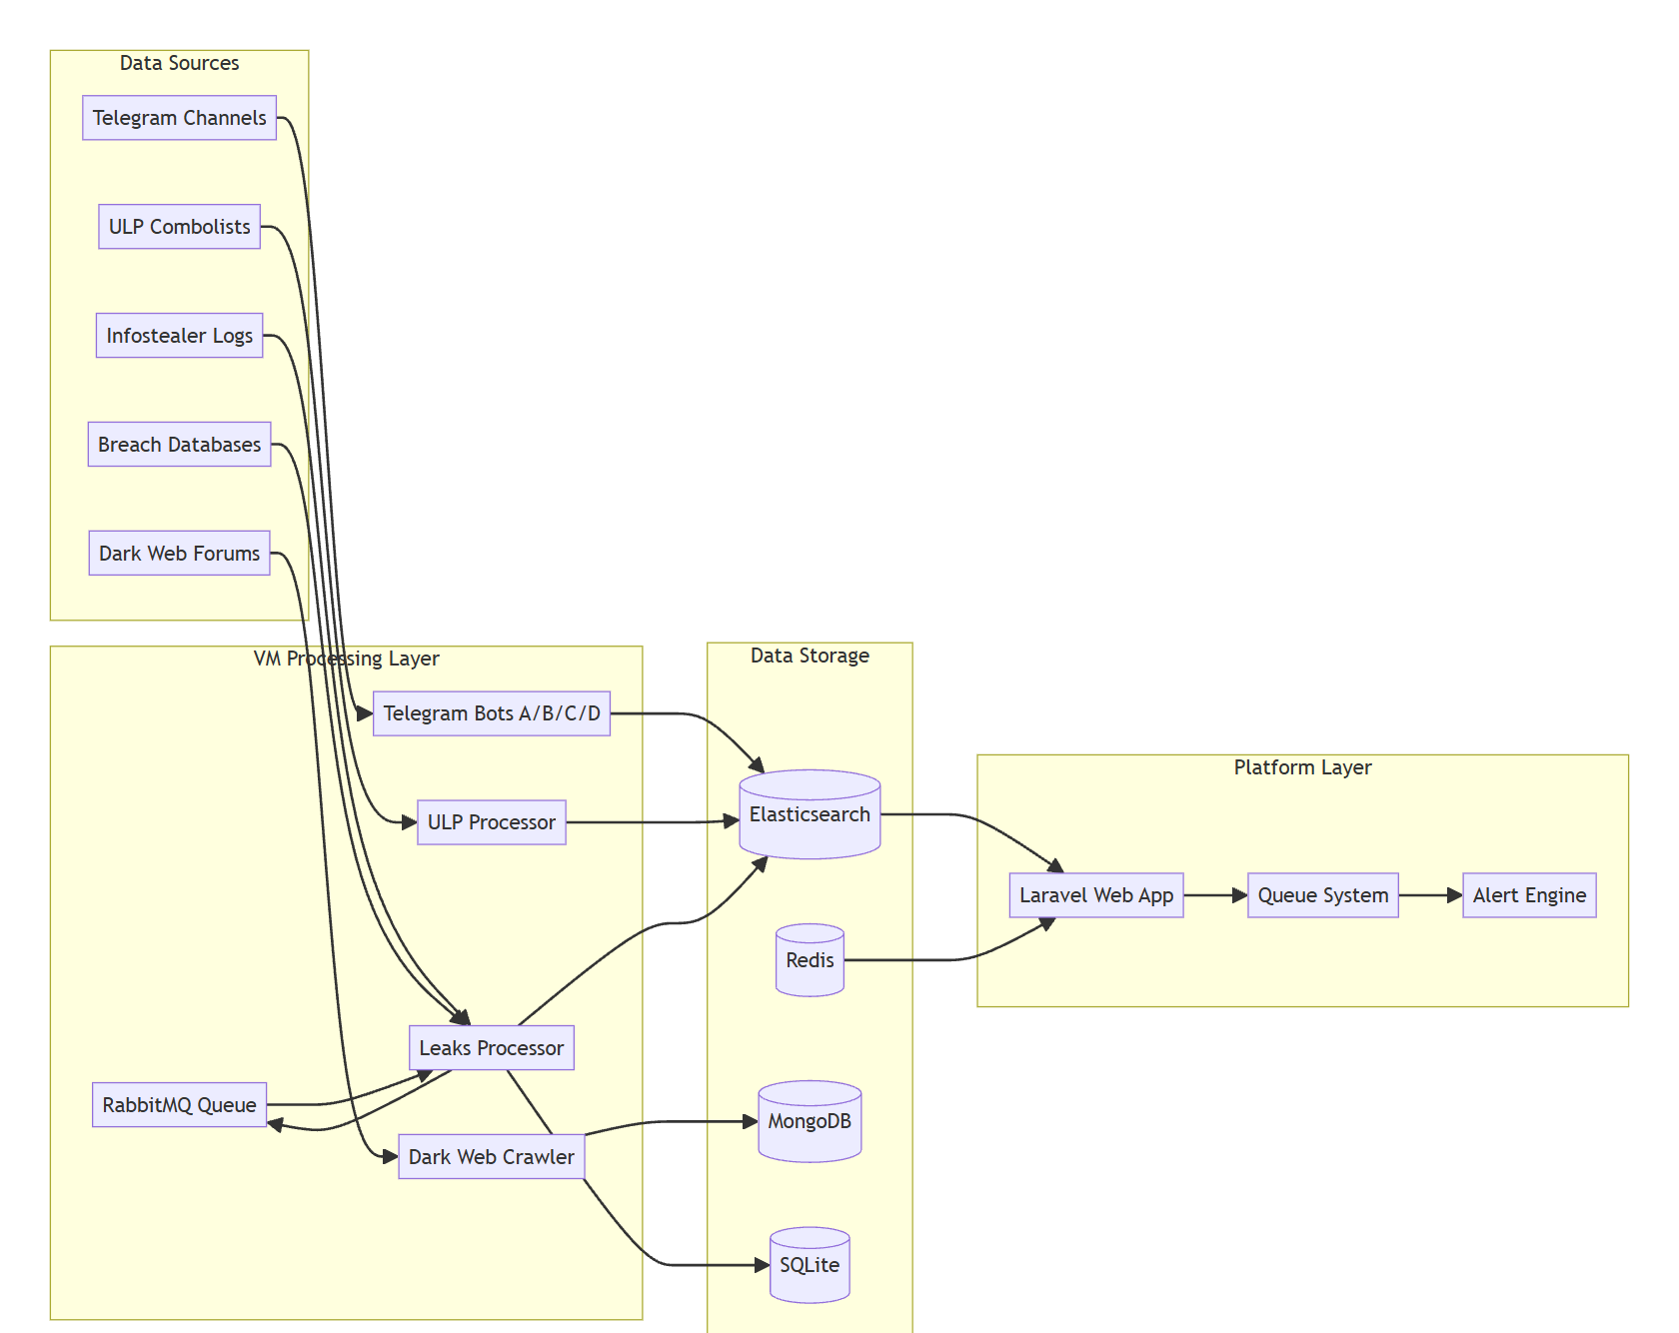
Overall System Architecture

5.2 Purpose of Document
- Define functional and non-functional requirements.
- Describe system architecture and component interactions.
- Model data structures through Entity-Relationship Diagrams.
- Illustrate data flow from collection to presentation.
- Define user interactions through Use Case and Sequence Diagrams.

5.3 Project Requirements Analysis

5.3.1 Functional Requirements
ID | Requirement | Category
FR-01 | Users shall register as Personal or Enterprise accounts | Authentication
FR-02 | Users shall authenticate via email/password or social login | Authentication
FR-03 | Multi-factor authentication via TOTP shall be supported | Authentication
FR-04 | Enterprise users shall verify domain ownership via DNS TXT records | Authentication
FR-05 | Users shall add emails, phones, domains for monitoring | Monitoring
FR-06 | The system shall scan monitored emails for breach exposure | Monitoring
FR-07 | Users shall view exposed data across 10 exposure categories | Exposure
FR-08 | Sensitive data shall be masked with password re-verification | Exposure
FR-09 | The system shall generate alerts on new exposures | Alerting
FR-10 | Alerts shall be delivered via dashboard, Telegram, and email | Alerting
FR-11 | Users shall manage alert preferences and thresholds | Alerting
FR-12 | Enterprise users shall manage organizations and teams | Enterprise
FR-13 | The VM shall consume search jobs from Redis queues | Data Collection
FR-14 | Telegram bots shall search credential databases | Data Collection
FR-15 | ULP processor shall search 2.4B combolists via ripgrep | Data Collection
FR-16 | Leaks processor shall process breach data from RabbitMQ | Processing
FR-17 | The system shall index processed data into Elasticsearch | Processing
FR-18 | Users shall generate PDF, CSV, JSON exposure reports | Reporting
FR-19 | Users shall schedule recurring reports | Reporting
FR-20 | AI-powered insights on alerts shall be provided | AI

Table: Functional requirements

5.3.2 Non-Functional Requirements
ID | Requirement | Category
NFR-01 | Elasticsearch for fast full-text search across breach data | Performance
NFR-02 | Redis for caching and queue management | Performance
NFR-03 | Data encrypted in transit (HTTPS) and at rest | Security
NFR-04 | Password hashes using bcrypt | Security
NFR-05 | API access via Sanctum tokens | Security
NFR-06 | VM runs Python 3.11+ daemon processes | Reliability
NFR-07 | RabbitMQ consumers auto-reconnect on connection loss | Reliability
NFR-08 | Redis workers use BRPOP for efficient job consumption | Performance
NFR-09 | SQLite (dev) and MySQL/PostgreSQL (prod) support | Compatibility
NFR-10 | Responsive UI supporting desktop, tablet, mobile | Usability

Table: Non-functional requirements

5.4 Software Architecture [ERD]
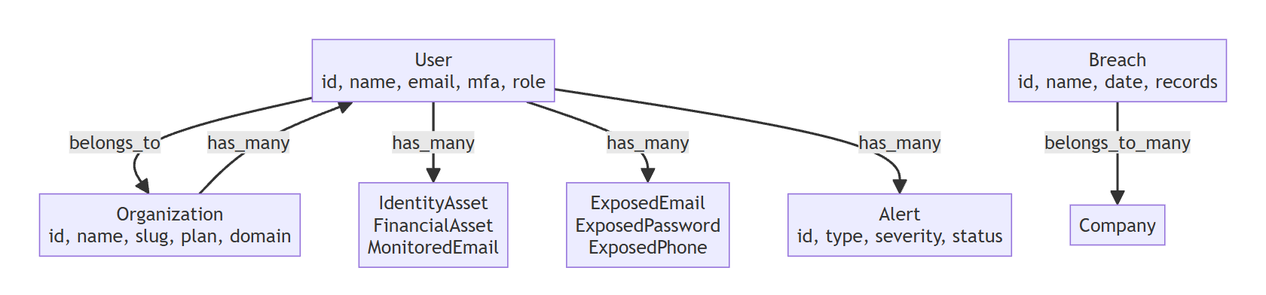
Entity-Relationship Diagram (ERD)

5.4.1 Platform Database Schema
The platform uses over 50 tables. Core entity relationships:

User & Organization
Users belong to Organizations (Enterprise) or operate independently (Personal). Organizations have managers, members, and monitored assets. Users have identity assets, financial assets, and monitored emails.

Exposure & Breach Data
Exposure data is organized across 14 specialized tables (ExposedEmail, ExposedPassword, ExposedFinancialData, ExposedPhone, ExposedPhysicalAddress, ExposedIdNumber, ExposedIpAddress, ExposedUsername, ExposedHwid, ExposedBrowserCookie, ExposedBrowserAutofill, ExposedServerCredential, ExposedMessengerSession, ExposedDeviceArtifact).

Alert & Notification
Alerts have severity (Critical/High/Medium/Low), status (New/Acknowledged/Dismissed/Resolved), source attribution, AI insights, and recommended actions. Notifications track delivery via Telegram and email.

5.4.2 Elasticsearch Data Model
- leaks-{breach_name} - Breach database records.
- leaks-{breach_name}-live - Streaming breach data.
- leaks-structure-{name} - Directory tree indexes.
- leaks-assets-{name} - Forensic asset metadata.
- *-leaks-schema - Bring Database schema
- ulp-2b4-{type}-{value} - ULP combolist results.
- {bot-name} - Telegram worker results (ak-bot, busc-bot, etc.).
- infostealer-logs - Infostealer malware log data.

5.5 Data Flow Diagram
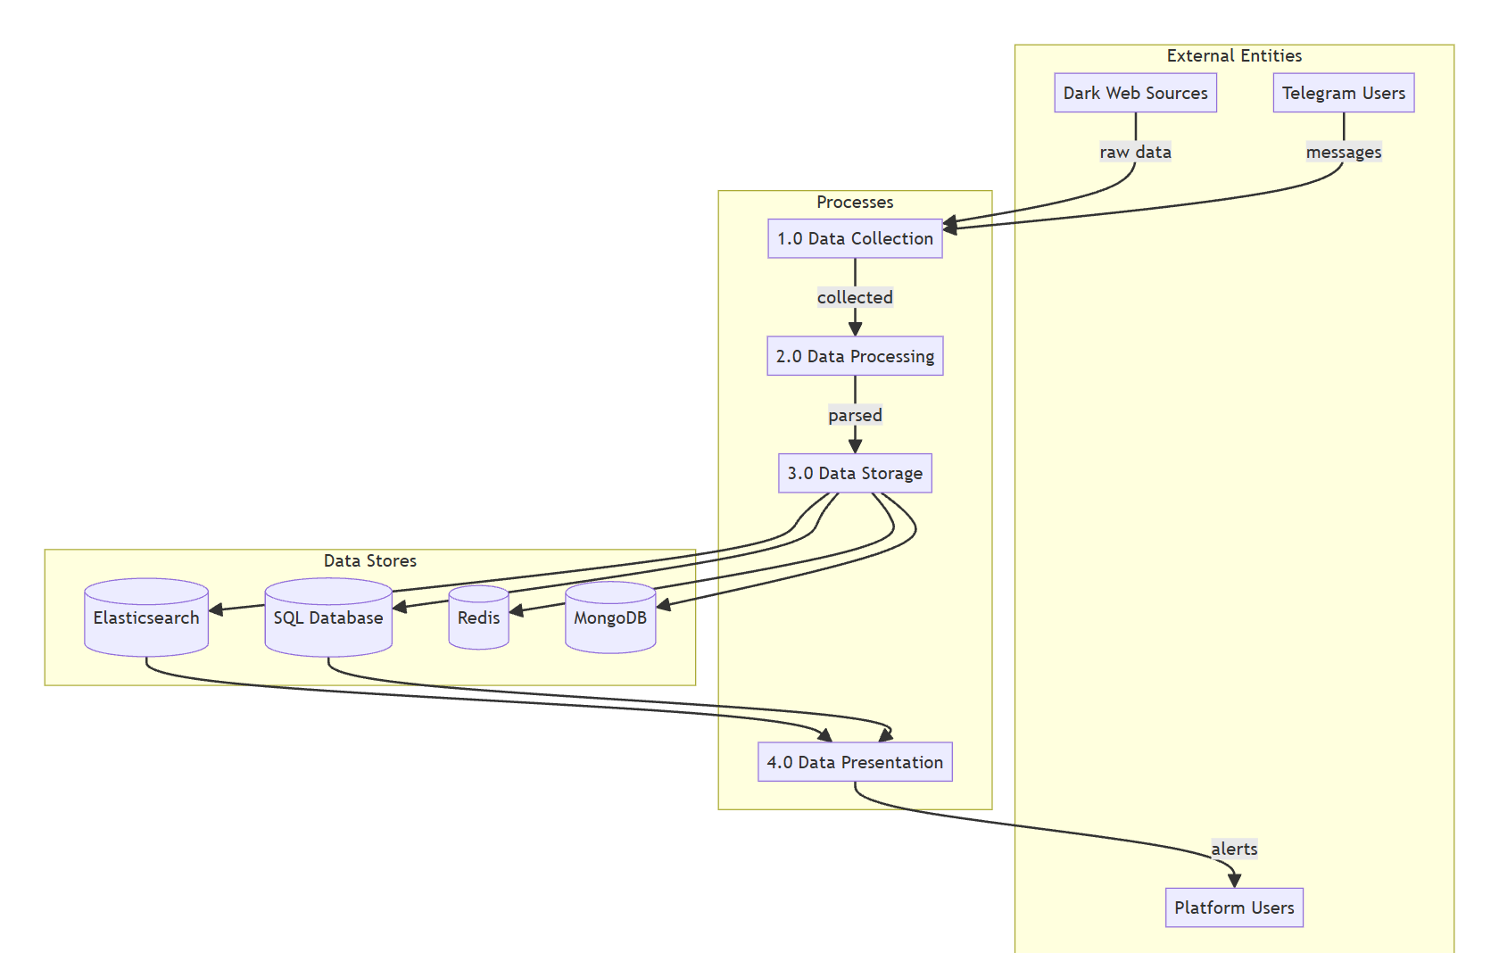
Data Flow Diagram (DFD)

5.5.1 Data Collection Layer
- Telegram Bots (4 workers): Connect via Telethon, consume Redis queue jobs, query credential-searching Telegram bots, collect responses (text/CSV), parse credentials, index to Elasticsearch.
- ULP Processor: Uses ripgrep to search 2.4B combolist files. Three-stage parsing: regex → knowledge base → AI (Ollama). Bulk-indexes to Elasticsearch.
- Leaks Processor: RabbitMQ consumer daemon processing breach files through classifier → parser → normalizer → uploader pipeline. Supports archives, forensic assets, streams.
- Dark Web Crawler: Scrapes BreachForums, stores thread/post data in MongoDB with SHA-256 dedup hashes.
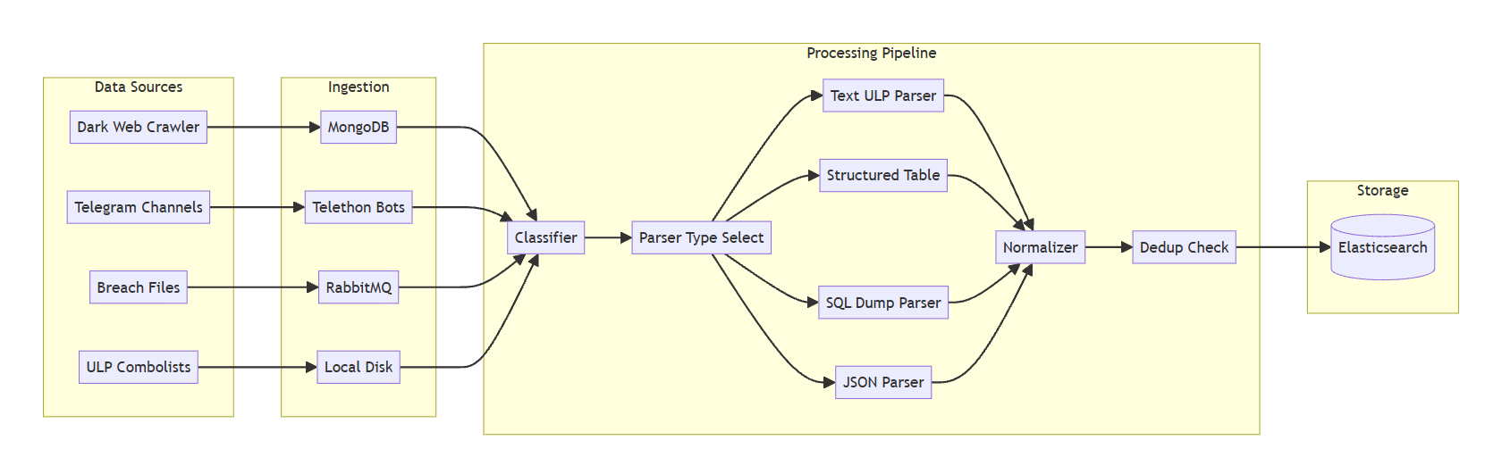
Data Collection & Processing Pipeline

5.5.2 Data Processing Layer
- Classification: Files classified by type (structured_table, sql_dump, json, ulp), format (CSV, TSV, plain text), mode (batch, stream, archive, forensic).
- Parsing: Specialized parsers: TextULPParser (combo lists), StructuredTableParser (CSV/TSV), SQLDumpParser (MySQL dumps), JSONParser (JSON/JSONL).
- Normalization: Records normalized into consistent schema with identity pillars, address fields, financial fields, metadata. Modes: identity, transaction, AI-assisted.
- Deduplication: SHA-256 hashing. In-memory and Redis-based registries.
- Upload: BatchUploader buffers and bulk-indexes to Elasticsearch (configurable batch size 500-1000).

5.5.3 Data Presentation Layer
Dashboard, Exposure Center, Alert Center, Search, Reports (PDF/CSV/JSON), Email/Telegram notifications.

5.6 System Design [Use Case Diagram]

5.6.1 Actor Identification
Actor | Description | Plan
Guest User | Unregistered visitor | N/A
Personal User | Individual monitoring personal footprint | Personal
Enterprise Manager | Organization admin | Enterprise
Enterprise Member | Limited access team member | Enterprise
Super Admin | Platform administrator | Admin
Telegram Bot Worker | Automated VM bot (4 instances) | System
ULP Processor | Combolist search script | System
Leaks Processor | RabbitMQ breach processor | System
Crawler Agent | Dark web forum scraper | System
Elasticsearch | Data store | System
Redis Queue | Message broker | System

Table: System actors
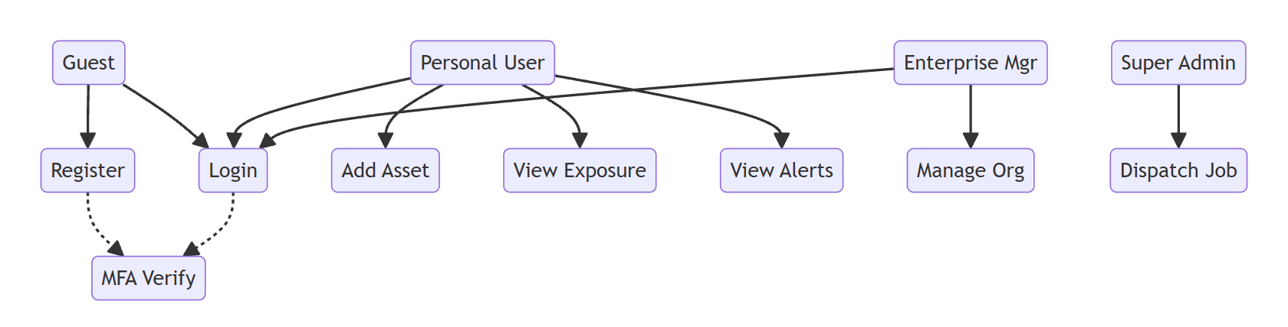
Use Case Diagram

5.6.2 Primary Use Cases
- Register Account - Personal or Enterprise with email/password or social login.
- Verify Email - OTP or signed URL verification.
- Set Up MFA - TOTP configuration with backup codes.
- Add Monitored Asset - Email, phone, domain, or identity asset.
- View Dashboard - Risk scores, exposure summaries, AI brief.
- Browse Exposures - 10 categories with detailed records.
- Verify Password for Sensitive Data - Re-enter password.
- Manage Alerts - View, acknowledge, dismiss, resolve.
- Configure Notifications - Channels and severity thresholds.
- Connect Telegram - Link account for bot notifications.
- Run Intelligence Search - Across ULP and Telegram databases.
- Generate Report - PDF, CSV, or JSON formats.
- Schedule Report - Recurring report generation.
- Manage Organization (Enterprise) - Settings, team, assets.

5.7 Sequence Diagram
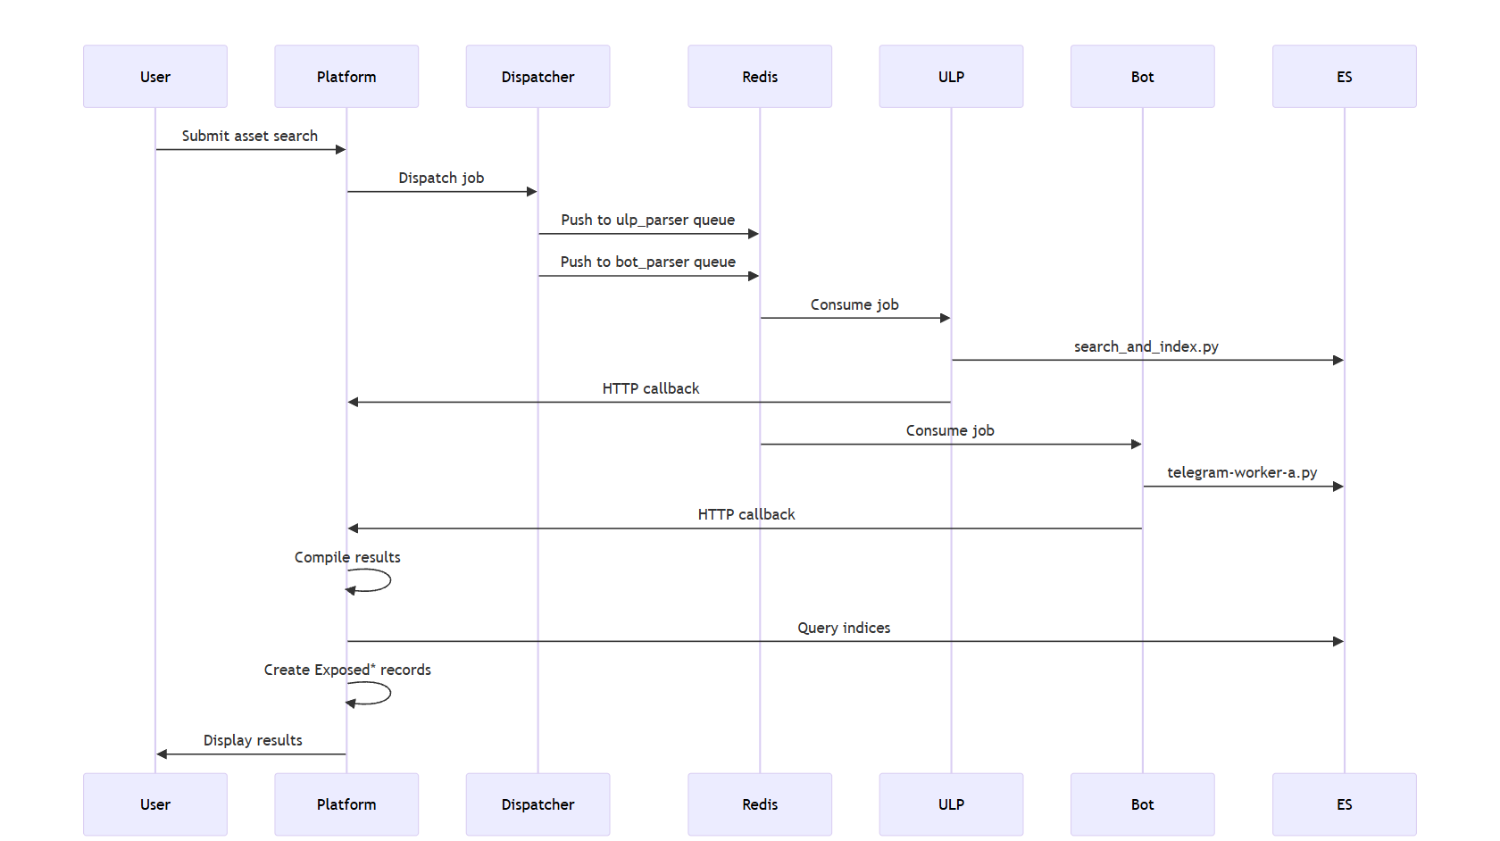
Asset Search Flow

5.7.1 Asset Search Flow
- 1. User initiates search (email, domain, phone, etc.).
- 2. AssetIntelDispatcher detects asset type, creates job ID.
- 3. Enforces plan limits (Personal: 3/day, Enterprise: unlimited).
- 4. Job pushed to Redis queues: queues:ulp_parser, queues:bot_parser.
- 5. CompileThreatIntelResults dispatched locally.
- 6. ULP Redis worker runs search_and_index.py.
- 7. Bot Redis workers run telegram-worker-*.py.
- 8. Workers send HTTP callbacks to /api/v1/jobs/callback.
- 9. CompileThreatIntelResults queries Elasticsearch.
- 10. Results imported into Exposed* models; alerts generated.
- 11. Results displayed in platform interface.
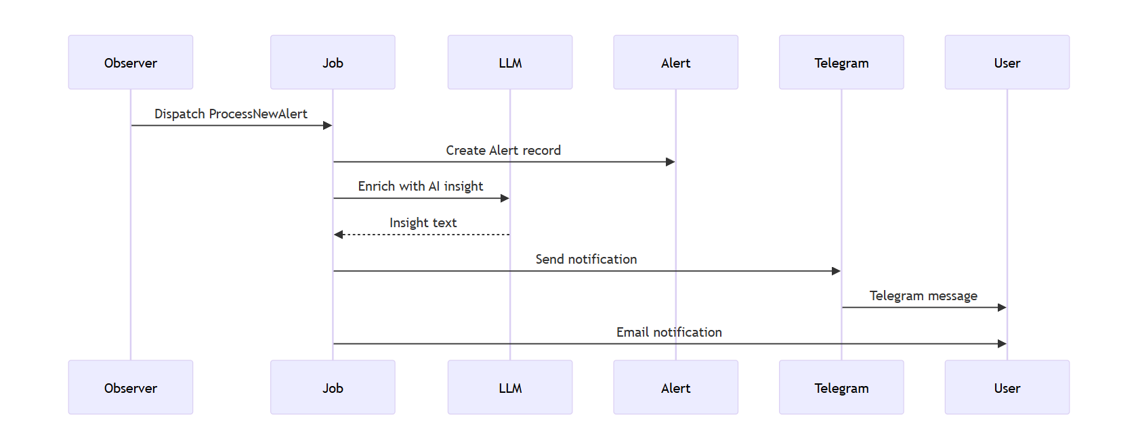
Alert Generation Flow

5.7.2 Alert Generation Flow
- 1. ExposureObserver detects new Exposed* record creation.
- 2. Dispatches ProcessNewAlert job to queue.
- 3. Creates Alert record with severity, source, type.
- 4. Alert enriched with AI insights via LocalLlmService.
- 5. SendTelegramAlert dispatched for Telegram-connected users.
- 6. AlertNotificationMail sent to user email.
- 7. Enterprise team members notified if configured.
- 8. Alert appears in dashboard feed in real-time.
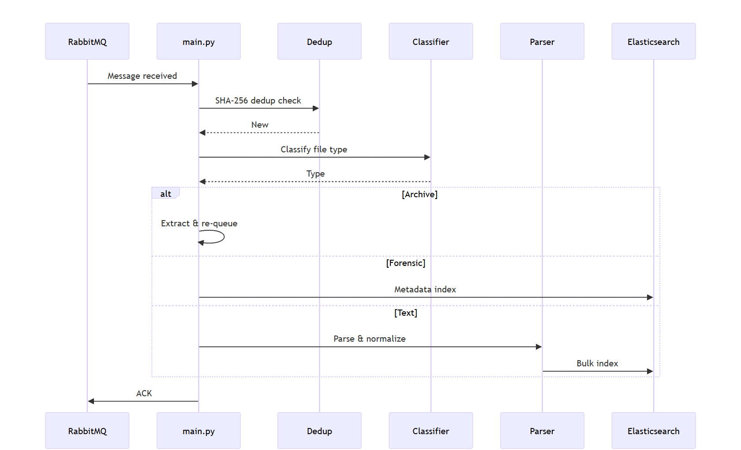
Breach Ingestion Flow

Chapter 6: Project Software Tools & Technologies
DarkTrace is built on a modern technology stack combining proven enterprise frameworks with specialized cybersecurity tools.
Technology | Version | Purpose | Component
Laravel | 12.x | Backend web framework | Platform
PHP | 8.2+ | Server-side language | Platform
Python | 3.11+ | Data processing/automation | VM
Elasticsearch | 8.12.2 | Full-text search & storage | Both
Redis | Alpine | Cache, sessions, queue | Both
RabbitMQ | Latest | Message broker | VM
Kibana | 8.12.2 | ES visualization | VM
Tailwind CSS | 4.x | CSS framework | Platform
Alpine.js | 3.x | JS interactivity | Platform
Vite | 7.x | Build tool | Platform
Telethon | Latest | Telegram MTProto client | VM
Laravel Sanctum | 4.x | API authentication | Platform
Laravel Socialite | 5.x | Social login | Platform
DOMPDF | 3.x | PDF generation | Platform
Google2FA | 9.x | TOTP MFA | Platform
Predis | * | Redis client for Laravel | Platform
Ollama | Latest | Local LLM hosting | VM
Ripgrep | Latest | Fast file search | VM
pika | Latest | RabbitMQ Python client | VM
tldextract | 5.x | Domain extraction | VM

Table: Technology stack
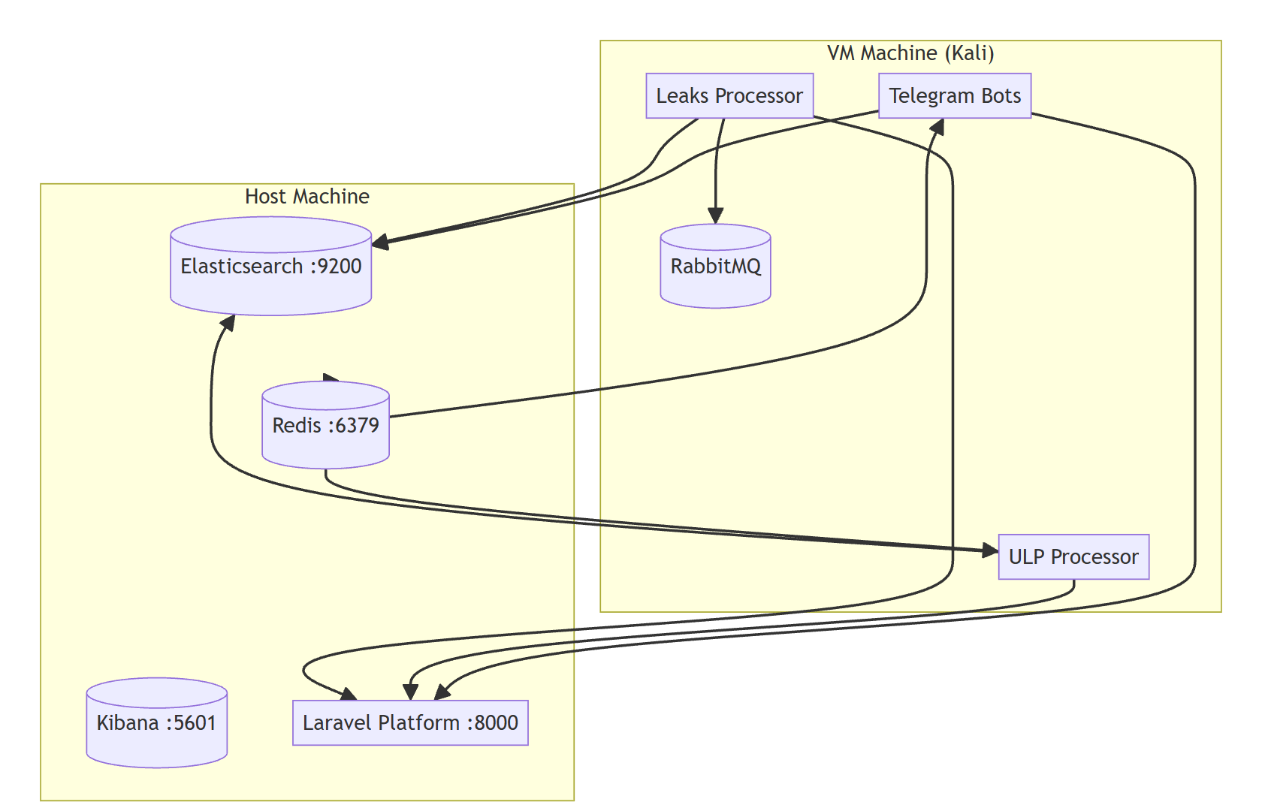
Deployment Architecture

6.1 Platform Technologies

6.1.1 Laravel Framework
Laravel 12 serves as the foundation of the web platform. It provides an MVC architecture, authentication, authorization, routing, middleware, database management, scheduling, queue management, and API development. Laravel simplifies application development while maintaining high security and maintainability.
Key Laravel components include:
- Laravel Sanctum for API authentication
- Laravel Socialite for Google and Microsoft login
- DOMPDF for PDF report generation
- Google2FA for Multi-Factor Authentication (MFA)

6.1.2 Frontend Stack
The frontend is built using modern web technologies that provide a responsive and intuitive user interface.
- Tailwind CSS 4 provides a utility-first styling framework.
- Alpine.js adds lightweight interactivity without requiring a full SPA framework.
- Vite offers fast development, hot module replacement, and optimized production builds.
- Axios is used for communication with backend APIs.## 6.1.3 Database Technologies
SQLite for local development, with MySQL/PostgreSQL support for production. 75+ migration files define the complete schema with rollback capabilities.

6.1.2 Database Technologies
The platform uses relational databases for application data.
- SQLite is used during development.
- MySQL or PostgreSQL are supported for production deployment.
Laravel migrations provide version-controlled database schema management.

6.2 VM Technologies

6.2.1 Python Ecosystem
- Telethon: Pure Python MTProto library for Telegram client automation. Enables searching credential databases through Telegram bots.
- Elasticsearch Python Client: Official client for all VM indexing and search operations. Supports bulk operations with configurable batch sizes.
- pika: Pure Python RabbitMQ client used by leaks processor for consuming messages with ACK/NACK, dead-letter queues, and auto-reconnection.
- redis-py: Python Redis client used by workers for BRPOP queue consumption.
- requests: HTTP library for Ollama AI API calls and Laravel callback notifications.
- tldextract: Domain extraction from URLs and email addresses.

6.2.2 Elasticsearch
Elasticsearch 8.12.2 provides full-text search across billions of records, flexible schema for diverse breach formats, powerful aggregations for statistics and trends, bulk indexing for efficient ingestion, scroll/pit for large result sets, and index lifecycle management. Organized by source: leaks-*, ulp-2b4-*, bot-name, infostealer-logs.

6.2.3 Redis
Redis serves as: Message Queue (queues:ulp_parser, queues:bot_parser with BRPOP consumption), Job Tracking (pending_worker counts, asset metadata), Rate Limiting (daily scan limits with 24h TTL), and Cache (Laravel config/routes/views).

6.2.4 RabbitMQ
Used by the Breach Processing Engine with persistent messages (delivery_mode=2), dead-letter queue for failures, auto-reconnection with heartbeat management, and fair dispatch (prefetch_count=1).

6.2.5 Artificial Intelligence Technologies
Artificial intelligence enhances the platform's ability to process unknown and heterogeneous data formats automatically.

Ollama
Ollama provides a local environment for running large language models without relying on external cloud services, improving both privacy and operational independence.

Qwen2.5:3b
The Qwen2.5:3b language model is integrated with Ollama to perform AI-assisted schema detection and intelligent data parsing. When traditional parsing methods fail, the AI analyzes incoming data samples, identifies their structure, and generates parsing rules that allow the platform to process previously unseen formats automatically.
This approach improves parsing accuracy while reducing manual development effort.

6.2.6 ripgrep (rg)
Ultra-fast regex search tool used by the ULP processor to search 2.4B record combolist files. Uses parallel processing and SIMD acceleration with thread count matching CPU cores.

6.3 Deployment & Infrastructure
The platform follows a distributed deployment architecture.
The web platform runs independently from the monitoring subsystem, allowing both components to scale independently according to workload.
The infrastructure includes:
- Docker containers for core services
- Elasticsearch cluster
- Redis server
- RabbitMQ broker
- Kibana for Elasticsearch visualization
- Dedicated Monitoring Virtual Machine running Python services
- Nginx or Apache as the production web server
This architecture improves scalability, reliability, and ease of maintenance.

6.3 Monitoring & Data Collection Technologies
The monitoring subsystem relies on several specialized technologies for collecting cyber threat intelligence.

Scrapling
Scrapling is used for stealth web scraping and anonymous crawling of dark web forums. Its anti-detection capabilities improve crawling reliability against protected websites.

Playwright
Playwright automates browser interactions for websites requiring JavaScript rendering. It enables reliable collection of dynamic content while supporting Chromium-based browsers.

Tor Network
The Tor network enables secure access to hidden (.onion) services. All crawler traffic is routed through Tor proxies to preserve anonymity during monitoring operations.

Telethon
Telethon is the official Python MTProto client used to communicate with Telegram. It enables automated interaction with Telegram channels and credential-search bots.

ripgrep
Ripgrep (rg) is used for extremely fast searching within large credential datasets. Its high-performance search engine significantly improves the efficiency of processing billions of records.

tldextract
tldextract is used to accurately extract domains and subdomains from URLs and email addresses during data normalization.

Chapter 7: Testing
Testing is a critical phase in the development of DarkTrace, ensuring that all platform components operate correctly both individually and as an integrated system. The testing process was designed to verify the correctness, reliability, security, and performance of the web platform, monitoring services, and virtual machine components. A multi-level testing strategy was adopted, consisting of unit testing, integration testing, smoke testing, end-to-end testing, and performance evaluation.
The testing activities were conducted throughout the Agile development lifecycle rather than being postponed until the end of development. Individual components were validated during implementation, followed by integration tests whenever new services were introduced. Before each major release, complete end-to-end workflows were executed to ensure that data collection, processing, storage, and presentation functioned together without errors.
The testing environment closely replicated the production deployment. The Laravel platform was executed using SQLite for isolated application testing, while Elasticsearch, Redis, RabbitMQ, and Kibana were deployed through Docker containers. The Python monitoring services were executed on a dedicated Linux virtual machine running Python 3.11. Test datasets included sample breach databases, Telegram responses, structured CSV files, SQL dumps, and infostealer logs to simulate real-world scenarios.
Automated testing was implemented using Pest/PHPUnit for the Laravel platform and Python testing utilities for the monitoring services. Continuous testing was performed during development to identify regressions early and maintain software stability.

7.1 Platform Testing

7.1.1 Test Framework
Pest PHP 3.x with PHPUnit. Tests organized into Feature and Unit:
- Feature/Auth/AuthenticationTest.php - Login, logout, auth flows.
- Feature/Auth/EmailVerificationTest.php - OTP verification.
- Feature/Auth/PasswordConfirmationTest.php - Password confirmation.
- Feature/Auth/PasswordResetTest.php - Forgot/reset flow.
- Feature/Auth/PasswordUpdateTest.php - Password update.
- Feature/Auth/RegistrationTest.php - Personal and Enterprise registration.
- Feature/AssetIntelDispatcherTest.php - Asset type detection and job dispatch.
- Feature/DeviceLookupTest.php - Device lookup service.
- Feature/ElasticsearchDataParserTest.php - ES flattening and import.
- Feature/FinancialMonitorTest.php - Financial asset monitoring.
- Feature/ProfileTest.php - Profile management.

7.1.2 Test Execution
php artisan config:clear --ansi
php artisan test
Uses SQLite for fast, isolated test execution. Test factories (UserFactory.php) generate data.

7.1.3 Development Test Scripts
35+ scratch/test scripts for manual component testing:
- test_es_performance.php - ES query performance.
- test_pipeline_end_to_end.php - Full pipeline.
- test_models.php - Model relationships.
- test_dispatcher.php - Asset dispatcher.
- test_db_redis.php - Redis queue integration.
- test_plan_limits_and_middleware.php - Plan constraints.
- test_financial_assets.php - Financial detection.
- test_verify_flow.php - Email verification.
- test_leaks_nested.php - Nested log flattening.
- simulate_user_adding_asset.php - User workflow.
- check_db.php, check_es_records.php - Data verification.

7.2 VM Component Testing

7.2.1 Smoke Tests
A dedicated _smoke_test.py utility validates the operational readiness of the monitoring environment before production deployment.
The smoke test verifies:
- RabbitMQ connectivity
- Elasticsearch connectivity
- File classification engine
- Parser initialization
- Deduplication registry
- End-to-end ingestion pipeline
Successful execution confirms that all monitoring services are functioning correctly.

7.2.2 Parser Testing
Dataset | Parser | Format
7.6k combo lists | text_ulp_parser | Plain text
Egypt Facebook Scrape | structured_table_parser | CSV (positional)
forum.kaspersky | structured_table_parser | CSV (semicolon)
Nafham SQL dump | sql_dump_parser | MySQL dump
Bazookaegy CSV | structured_table_parser | CSV
Udemy transactions | structured_table_parser | CSV (transactions)
Instagram combo | structured_table_parser | Positional
Student records | structured_table_parser | AI mode
Russian passports | structural_index_handler | Directory tree

Table: Parser test datasets

7.2.3 Telegram Bot Parsing Testing
Each bot includes --test mode:
python telegram-worker-a.py --test path/to/file.txt
Testing verifies:
- Colon-delimited parsing
- Space-separated parsing
- Tab-delimited parsing
- Label-based formats
- CSV extraction
- URL normalization
- Duplicate removal
- Credential extraction accuracy

7.2.4 ULP Processor Testing
The ULP Processor was evaluated using large combolist datasets.
Validation included:
- Knowledge-base learning
- Temporary file reuse
- Failed-line logging
- Thread tuning
- Batch size optimization
- Fresh scans using --no-cache
These tests confirmed stable processing of billions of records while maintaining acceptable execution speed.

7.3 Integration Testing
Integration testing verified communication between all major platform components.
The following integrations were validated:
- Redis queue communication between Laravel and VM workers.
- RabbitMQ message delivery to breach processing services.
- Elasticsearch indexing and search operations.
- Callback handling through /api/v1/jobs/callback.
- Nested document flattening into Exposed* models.
- End-to-end ingestion pipeline from raw breach files to dashboard visualization.
A complete workflow test confirmed successful execution of the following sequence:
- Asset search request submitted by the user.
- Job dispatched to Redis queues.
- Telegram workers and ULP processor execute searches.
- Results indexed into Elasticsearch.
- Data imported into platform database.
- Alerts generated.
- Dashboard updated in real time.

Chapter 8: Future Works & Conclusion**

8.1 Future Work Features

Although DarkTrace currently provides a comprehensive platform for dark web monitoring and cyber threat intelligence, there are several opportunities for future enhancement that can further improve its capabilities, scalability, and effectiveness. The future roadmap focuses on expanding intelligence sources, enhancing automation, improving security, and incorporating advanced artificial intelligence techniques.
One of the primary future enhancements is the integration of Machine Learning for predictive threat analysis. Instead of relying solely on rule-based detection mechanisms, future versions of the platform will utilize machine learning models to classify threats, predict credential abuse, and detect anomalous activities within collected datasets. Predictive threat scoring and behavioral profiling will help security analysts prioritize critical incidents while reducing false-positive alerts.
Another important enhancement is expanding the platform's monitoring capabilities beyond traditional dark web forums and Telegram channels. Future versions will support monitoring ransomware leak sites, Pastebin, GitHub repositories, criminal marketplaces, invite-only communities, and additional underground communication platforms. Mobile application analysis, including APK decompilation and hardcoded secret detection, will also be incorporated to provide broader threat intelligence coverage.
The platform will also introduce advanced dashboard capabilities through real-time WebSocket communication, replacing periodic polling with live updates. Additional Elasticsearch-powered search features, including advanced query builders, saved searches, and personalized dashboard widgets, will improve usability for enterprise users.
Security improvements are also planned. Future releases will support WebAuthn/FIDO2 passwordless authentication, granular role-based access control (RBAC), and intelligent session analysis that evaluates login context and user behavior to detect suspicious authentication attempts.

8.2 Future Plans

8.2.1 Market Expansion
Future versions of DarkTrace aim to support a wider range of organizations through:
- Multi-tenant deployment for Managed Security Service Providers (MSSPs).
- White-label deployment for enterprise customers.
- API-first integration with third-party security platforms.
- Regional threat intelligence supporting Arabic, European, and Asian languages.
- Industry-specific deployments targeting healthcare, finance, education, and government sectors.

8.2.2 Technical Evolution
From a technical perspective, several infrastructure improvements are planned.
The current Docker-based deployment can be extended using Kubernetes orchestration to support automatic scaling, fault tolerance, and simplified cluster management. Event-driven architectures utilizing Apache Kafka or AWS SQS may replace parts of the existing queue infrastructure to improve scalability and throughput.
Real-time stream processing technologies such as Apache Flink or Kafka Streams can also be introduced to reduce processing latency and support near real-time threat intelligence analysis across continuously growing datasets.

8.3 Impact of The Future Work on Project
The proposed future enhancements will significantly increase the overall value and effectiveness of DarkTrace.
The introduction of machine learning models will improve threat detection accuracy while reducing false-positive alerts, allowing analysts to focus on genuinely critical incidents. Expanding monitoring sources will increase the platform's visibility across the cyber threat landscape and improve early detection of compromised credentials and leaked information.
Enterprise-oriented features such as advanced RBAC, WebAuthn authentication, and API integrations will improve organizational security and simplify deployment in large environments. Infrastructure improvements based on Kubernetes and event-driven processing will increase scalability and enable the platform to support significantly larger datasets and user populations.
Automation through SIEM and SOAR integration will also reduce manual intervention by allowing organizations to trigger automated incident response actions based on newly discovered threats.
Overall, these future developments will transform DarkTrace from a monitoring platform into a comprehensive cyber threat intelligence ecosystem capable of supporting both individual users and enterprise security operations.

8.4 Conclusion
DarkTrace represents a comprehensive approach to dark web monitoring and cyber threat intelligence. The platform successfully addresses the critical challenge of detecting compromised data and credentials across multiple dark web sources, delivering actionable intelligence to both individual users and enterprise organizations.
Key achievements:
- Multi-source dark web intelligence collection across 4 Telegram bot workers, a 2.4B record ULP pipeline, a RabbitMQ-powered breach processing engine, and a dark web forum crawler.
- Intelligent data processing with three-stage parsing (regex → knowledge base → AI), supporting structured tables, SQL dumps, JSON, CSV, plain text, and nested infostealer logs.
- Comprehensive exposure management across 10 data categories with real-time alerting via web, Telegram, and email.
- Enterprise-grade features including organization management, domain verification, team collaboration, and multi-asset monitoring.
- Modern, responsive web interface built with Laravel, Tailwind CSS, and Alpine.js.
- Strong security: MFA (TOTP), email OTP, password-protected views, audit logging, rate limiting.
DarkTrace is built with extensibility in mind, using open-source technologies and following industry best practices. The modular architecture allows easy addition of new sources and capabilities as the threat landscape evolves.
In conclusion, DarkTrace successfully demonstrates that comprehensive, real-time dark web monitoring is achievable using modern, open-source technologies, providing a practical, scalable solution to the growing problem of data breaches and credential exposure.
- End of Document -

